***Science* Manuscript Template Instructions**

**General instructions on using this template and submitting a manuscript to *Science*:** Thank you for preparing a manuscript for submission to *Science*. Using this template, or following the guidelines below, will help us in processing your paper and completing the manuscript’s record in our system. Our goal is to automatically identify each section of your manuscript so that we can accurately extract title, authors, abstract, etc. and to enrich it by including reference links and an accurate layout.

Please use the actual template, which starts on page 2. When you are ready to submit, please delete the text on this cover page.

You can submit your paper at <https://cts.sciencemag.org>. Additional information for authors is available at [http://www.sciencemag.org/authors/science-information-authors](http://www.sciencemag.org/site/feature/contribinfo/index.xhtml).

If you are using LaTeX, please convert your paper into a Word .docx file. If this is not possible, please use our LaTeX template (available [here](http://www.sciencemag.org/authors/preparing-manuscripts-using-latex)) and upload a PDF version of your paper. Some conversion approaches are available here: <http://www.tug.org/utilities/texconv/textopc.html>.

So that we can extract parts of your paper (even if you do not use this template), begin each section with the specific words listed below, some of which are followed by a colon. Do not use paragraph breaks in the title, author list, or abstract. The author list, corresponding author email(s), and affiliation(s) should be checked carefully because they will be published as listed in the manuscript.

**Title:** No more than 96 characters and spaces, lacking jargon and abbreviations where possible.

**Authors:**

**Affiliations:**

**Abstract:** 125 words or less.

**One Sentence Summary:** No more than 125 characters and spaces.

**Main Text:**

**References and Notes:** Only a single numbered list should be provided for all references cited in the main text and in the supplementary materials.

**Acknowledgments:** Split into general, Funding, Author contributions, Competing interests, and Data and materials availability, as described in the template below.

**Supplementary Materials:** Include a list, noting which references are only cited in the SM.

**Fig. #.** (Begin each figure caption with a label, “**Fig. 1.**”, for example, as a new paragraph.)

**Table #.** (Begin each table caption with a label “**Table 1.**”, for example, as a new paragraph.)

Please use the .docx format (all versions after Word 2007 for PC and Word 2011 for Mac) and include page numbers in your submitted file. We also encourage use of line numbers. Supplementary Materials (comprising Materials and Methods, figures, and tables) should be in a separate file.

More specific formatting instructions are provided in the template that follows.

**Title: Protected area planning to conserve biodiversity in an uncertain world**

**Authors:** Richard Schuster 1,2*, Rachel Buxton1, Jeffrey O. Hanson1, Allison D. Binley1, Jeremy Pittman3, Vivitskaia Tulloch4, Frank A. La Sorte5, Patrick R. Roehrdanz6, Peter H. Verburg7, Amanda D. Rodewald5,8 , Scott Wilson1,9, Hugh P. Possingham10, Joseph R. Bennett1

**Affiliations:**

1 Department of Biology, 1125 Colonel By Drive, Carleton University, Ottawa ON, K1S 5B6 Canada.

2 Nature Conservancy of Canada, 245 Eglinton Ave East, Suite 410, Toronto, Ontario, M4P 3J1, Canada.

3 School of Planning, University of Waterloo, 200 University Ave W, Waterloo, ON, N2T 3G1, Canada

4 Conservation Decisions Lab, Department of Forest and Conservation Sciences, 2424 Main Mall, Vancouver, BC V6T 1Z4, Canada.

5 Cornell Lab of Ornithology, Cornell University, Ithaca, NY 14850, USA

6 Conservation International, 2100 Crystal Drive #600, Arlington, VA 22202, USA

7 Institute for Environmental Studies, VU University Amsterdam, Amsterdam, The Netherlands

8 Department of Natural Resources and the Environment, Cornell University, Ithaca, NY 14853, USA.

9 Wildlife Research Division, Environment and Climate Change Canada, 1125 Colonel By Drive, Ottawa, Ontario, Canada, K1S 5B6

10 Centre for Biodiversity and Conservation Science, University of Queensland, St Lucia, Queensland 4067, Australia

*Corresponding author. Email: [richard.schuster@glel.carleton.ca](mailto:richard.schuster@glel.carleton.ca)

**Abstract:** Despite being key instruments for conservation, protected areas are vulnerable to risks associated with weak governance, land-use intensification, and climate change. Using a hierarchical spatial optimization routine to maximize protection of all known terrestrial vertebrate species, we found that plans for expanding the global protected area system that explicitly account for such risks require small (1.6%) increases in land area relative to plans that do not consider risk. Among the three risk categories, the risk of governance failure drove the biggest changes in priority areas for protection. Conserving wide-ranging species required countries with relatively strong governance to protect more land when bordering nations with comparatively weak governance. Our results underscore the need for cross-jurisdictional coordination and demonstrate how risk can be efficiently incorporated into conservation planning.

**One-Sentence Summary:**

To safeguard biodiversity, protected area planning should incorporate risks associated with climate and land use change, and weak governance.

**Main Text:** Protecting habitat is one of the best strategies for stemming the alarming decline of biodiversity5. As such, international agreements to protect increasing amounts of land area have become cornerstones of efforts to protect biodiversity4. Most current approaches for identifying important areas to protect rely upon estimations of the conservation value of the land for biodiversity4,6,7. Seldom articulated in such plans is the tacit assumption that protection will be enforced, effective, and permanent; yet many protected areas are subject to risks caused by weak governance, land use intensification, and climate change. For example, political instability and corruption can reduce protected area effectiveness10,11. Likewise, high deforestation rates can increase the risk of degazetting protected areas and failing to meet protection goals12; and the increasing frequency and intensity of extreme weather events can threaten population persistence within protected areas13. Thus, effective use of limited conservation resources requires planning for investment in protected areas that accounts for these risks14,15. Here we demonstrate how accounting for governance, land-use, and climate risks influences decisions for establishing protected areas at a global scale and may ultimately improve the resilience of protected areas and the species they support16,17.

We considered the following three broad categories of risk, which we defined to be factors likely to diminish the long-term effectiveness of protected areas: (i) governance, (ii) land-use, and (iii) climate. For governance risk, we used a national-scale metric that combines six governance indicators from the World Bank18: accountability, political stability, government effectiveness, regulatory quality, rule of law, and control of corruption (Figure S1). For land-use risk, we estimated the average change in biodiversity per land-use category using methods19 that model the risk of biodiversity loss for land systems due to agricultural expansion and intensification (Figure S2). For climate risk, we used predicted climate velocity, which is the horizontal velocity along the Earth’s surface a hypothetical species would need to maintain a constant temperature as climate changes. In addition, to illustrate the effect of using alternative risk measures, we use the duration of extreme heat events, calculated using a probabilistic framework that estimates the novelty of temperatures relative to historical year-to-year variation from 1979 to 2019, identifying areas where extreme heat events are likely to have the most significant effects on biodiversity20 (see Supplementary Material for details). We used these three risk categories for illustrative purposes; the approach we propose is flexible and can easily incorporate additional risk metrics21.

We considered the influence of risk categories on allocating protection decisions at a global scale for suitable habitat for all 29,350 vertebrate species from the IUCN Red List of Threatened Species22 using a multi-objective optimization approach. To incorporate risk categories, we built on a classical problem formulation from the systematic conservation planning literature – the minimum set problem - where the objective is to reach species distribution protection targets, while accounting for one constraint such as land cost or area23–25. We expand this approach to include multiple objectives accounting for varying risk in the problem formulation, by treating each risk layer as a separate objective in the problem formulation26. We use a hierarchical approach that assigns a priority to each objective and optimizes for the objectives in decreasing priority order. At each step, the approach finds the best solution for the current objective, but only from among those that would not degrade the solution quality for higher-priority objectives.

In total 16 planning scenarios were created, such that solutions accounted for all possible combinations of risk categories within each hierarchical level (Table S1). We then compared these risk-based solutions to those produced with a null scenario that adopted the traditional area-minimizing approach to optimization without considering risk27. Because our scenarios aimed to build upon the current protected area portfolio globally, we incorporated current protected areas into our solutions. For each scenario we set species-based targets based on percentages of suitable habitat. Specifically, we obtained suitable habitat maps , and set target percentages for each species, from 100% for species with less than 1,000 km2 of suitable habitat to 10% for those with greater than 250,000 km2 of suitable habitat, and linearly interpolated on a log-linear scale between these thresholds.

Surprisingly, scenarios that incorporated combinations of the three risk categories increased the priority area by only 1.6% on average (0.08 – 2.52%) compared to the null scenario for protecting species’ suitable habitat. Thus, accounting for risks costs relatively little compared to the potential gains from selecting a more resilient conservation network (Figure 1). When only looking at scenarios that included one risk factor, climate change risk based on climate velocity required the greatest increase in global protected area, compared to scenarios only including governance or land use intensification risks (Table S1).

We found that protected areas identified across scenarios overlapped spatially, with the same 11.5 million km2 (7.8% of global land area) being prioritized for expansion of the current protected area system in at least eleven scenarios and 8.5 million km2 (5.8% of global land area) in all fifteen risk scenarios (Figure 2). These “no regrets” areas provide examples of places that should be immediate priorities for international agencies aiming to maximize the resilience of protected area networks, as they are robust to assumptions about the relative importance of risk factors. Example countries that have contiguous areas of high overlap among different scenarios are Canada, Kenya and Peru (Figure S4). There was considerable overlap among the priorities across scenarios within Conservation International’s global biodiversity hotspots28, but many high overlap areas lie either outside of (53.3%) or in small areas within hotspots (Figure S5).

However, there were some important shifts in locations identified as high priority for protection among scenarios (Figure 3; Table S2), with the largest shift being for the risk of weak governance (Figure S6). Compared to null scenarios, those considering governance risk required protection of greater land area, even for countries with relatively effective governance. This was especially true for protecting wide-ranging species and when neighboring countries had weak governance. For example, many vertebrate species ranges span northeastern Russia and Finland, with one of the most iconic being caribou (*Rangifer tarandus*), which has an IUCN conservation status of vulnerable. Because Russia suffers from low scores for ‘voice and accountability, rule of law, and control of corruption’ (Table S3), whereas Finland has relatively high governance scores, the scenarios including governance pressures led to a selection of 36.4% of Finland’s land area compared to the null scenario with 16.2% (Figure 4).

Land-use and climate change also influenced variation in priority locations for protection compared to the null scenario. For example, large areas of Sierra Leone are experiencing high risk of biodiversity loss due to expanding intensive land-use practices (Fig. S2), whereas this same risk is lower in neighboring Liberia. The scenario including land-use risk selected 32.1% of the land area in Liberia compared to 22.5% in the null scenario (Figure 4). Large areas of Hungary and Serbia have high predicted climate velocity (Fig. S3), whereas most of nearby Kosovo has lower predicted climate velocity. Scenarios including climate impact risk selected 20.4% of Kosovo’s land area compared to the null scenario with 10.2% (Figure 4). The alternative climate risk metric predicting frequency of extreme events[cite LaSorte] (Fig. S*) indicated different priority areas in some cases. For example, large areas of Libya, which is experiencing fewer extreme heat events than neighboring countries, were prioritized in this scenario and not in the null scenario. This difference between climate risk scenarios highlights the need for agencies to carefully consider their choices of risk metrics and suggests that smaller-scale planning exercises should choose metrics that are most relevant for each region.

Overall, our results emphasize the importance of coordinating initiatives to plan conservation across jurisdictions29 and identifying countries where collaborative opportunities promote resilient protected area systems. To illustrate this point, we consider the great green macaw (*Ara ambiguus*), with <2500 individuals remaining30 and a range that stretches from southern Honduras to western Colombia. Because great green macaw habitat spans several countries differing in governance, land use, and climate risk, coordinated efforts among countries will be necessary for the species to persist in the future. Such cooperative governance frameworks31 are especially important for countries supporting wide-ranging species that are expected to be impacted by climate, land-use, and governance risk across borders (Figure 3). These governance frameworks, both within and among countries, would need to be developed in an environmentally just and equitable way to deliver benefits to biodiversity and local communities32.

In contrast, few priorities changed - and protection needs remained high - for countries with high rates of endemism, even amid high risk from climate change, land uses, and weak governance. Moreover, some countries with a large proportion of their land already protected, such as Brazil, which has protected 30.3% of its land area, had lower differences between scenarios that incorporate risk and the null scenario, despite having high climate, land-use, and governance risk. This highlights the importance of further considering the effectiveness of existing protected areas in planning analyses, in tropical areas where cropland conversion in protected areas has increased to similar rates outside protected areas33.

Previous work has incorporated individual risk factors analogous to those we used, including governance1,34, climate change3 and land-use change2,35. Yet, our results show that protected area expansion decisions can be profoundly influenced by all three risk factors combined. Our flexible framework and methods can allow conservation agencies to set their own priorities from local to global scales and incorporate different metrics to assess the relevance of different forms and levels of risk .

The conservation community has traditionally neglected to estimate how future changes in climate37, land-use35, and socio-economic conditions might compromise the effectiveness of protected areas. Our results show that the spatial distribution of protected areas, rather than the land area *per se*, can be profoundly influenced by risk, particularly the risk of weak governance. Surprisingly, incorporating risk into decision-making adds <1% to the total global area required to meet biodiversity targets. Accounting for risk comes at limited extra cost, but this is likely outweighed by increased likelihood of achieving global biodiversity targets. Our results also emphasize the importance of cross-jurisdictional conservation initiatives, especially in adjacent countries sharing wide-ranging species where risk varies considerably from country to country. Considering risk in conservation decision-making will result in more resilient and effective conservation plans into the future to help safeguard our planet’s biodiversity in the face of the current extinction crisis.

**References and Notes**

1. Mascia, M. B. & Pailler, S. Protected area downgrading, downsizing, and degazettement (PADDD) and its conservation implications. *Conserv. Lett.* **4**, 9–20 (2011).

2. Pouzols, F. M. *et al.* Global protected area expansion is compromised by projected land-use and parochialism. *Nature* **516**, 383–386 (2014).

3. Hoffmann, S., Irl, S. D. & Beierkuhnlein, C. Predicted climate shifts within terrestrial protected areas worldwide. *Nat. Commun.* **10**, 1–10 (2019).

4. CBD (Convention on Biological Diversity). Aichi Biodiversity Targets. <https://www.cbd.int/sp/targets/> (2020).

4. CBD (Convention on Biological Diversity). Zero draft of the post-2020 global biodiversity framework. https://www.cbd.int/doc/c/efb0/1f84/a892b98d2982a829962b6371/wg2020-02-03-en.pdf (2020).

5. Watson, J. E., Dudley, N., Segan, D. B. & Hockings, M. The performance and potential of protected areas. *Nature* **515**, 67–73 (2014).

6. Brooks, T. M. *et al.* Global biodiversity conservation priorities. *science* **313**, 58–61 (2006).

7. Venter, O. *et al.* Targeting Global Protected Area Expansion for Imperiled Biodiversity. *PLOS Biol.* **12**, e1001891 (2014).

8. Baynham-Herd, Z., Amano, T., Sutherland, W. J. & Donald, P. F. Governance explains variation in national responses to the biodiversity crisis. *Environ. Conserv.* **45**, 407–418 (2018).

9. Miller, D. C., Agrawal, A. & Roberts, J. T. Biodiversity, governance, and the allocation of international aid for conservation. *Conserv. Lett.* **6**, 12–20 (2013).

10. Schulze, K. *et al.* An assessment of threats to terrestrial protected areas. *Conserv. Lett.* **11**, e12435 (2018).

11. Hammill, E., Tulloch, A. I. T., Possingham, H. P., Strange, N. & Wilson, K. A. Factoring attitudes towards armed conflict risk into selection of protected areas for conservation. *Nat. Commun.* **7**, 11042 (2016).

12. Tesfaw, A. T. *et al.* Land-use and land-cover change shape the sustainability and impacts of protected areas. *Proc. Natl. Acad. Sci.* **115**, 2084–2089 (2018).

13. Maxwell, S. L. *et al.* Conservation implications of ecological responses to extreme weather and climate events. *Divers. Distrib.* **25**, 613–625 (2019).

14. McBride, M. F., Wilson, K. A., Bode, M. & Possingham, H. P. Incorporating the effects of socioeconomic uncertainty into priority setting for conservation investment. *Conserv. Biol.* **21**, 1463–1474 (2007).

15. Alagador, D., Cerdeira, J. O. & Araújo, M. B. Shifting protected areas: scheduling spatial priorities under climate change. *J. Appl. Ecol.* **51**, 703–713 (2014).

16. McGowan, J. *et al.* Prioritizing debt conversion opportunities for marine conservation. *Conserv. Biol.* **34**, 1065–1075 (2020).

17. Kuempel, C. D., Jones, K. R., Watson, J. E. M. & Possingham, H. P. Quantifying biases in marine-protected-area placement relative to abatable threats. *Conserv. Biol.* **33**, 1350–1359 (2019).

18. Kaufmann, D., Kraay, A. & Mastruzzi, M. The Worldwide Governance Indicators: Methodology and Analytical Issues1. *Hague J. Rule Law* **3**, 220–246 (2011).

19. Kehoe, L. *et al.* Biodiversity at risk under future cropland expansion and intensification. *Nat. Ecol. Evol.* **1**, 1129–1135 (2017).

20. La Sorte, F. A., Johnston, A. & Ault, T. R. Global trends in the frequency and duration of temperature extremes. *Clim. Change Rev.*

21. Garcia, R. A., Cabeza, M., Rahbek, C. & Araújo, M. B. Multiple dimensions of climate change and their implications for biodiversity. *Science* **344**, 1247579 (2014).

22. IUCN. The IUCN Red List of Threatened Species. version 1.18. (2019).

23. Margules, C. R. & Pressey, R. L. Systematic conservation planning. *Nature* **405**, 243–53 (2000).

24. Moilanen, A., Wilson, K. & Possingham, H. *Spatial conservation prioritization: quantitative methods and computational tools*. (Oxford University Press, 2009).

25. Ball, I. R. R., Possingham, H. P. P. & Watts, M. E. E. Marxan and relatives: Software for spatial conservation prioritisation. in *Spatial conservation prioritisation: Quantitative methods and computational tools.* (eds. Moilanen, A., Wilson, K. & Possingham, H. P.) 185–195 (Oxford University Press, 2009).

26. Deb, K. Multi-objective optimization. in *Search methodologies* 403–449 (Springer, 2014).

27. Post-2020 Global Biodiversity Framework. *IUCN* https://www.iucn.org/theme/global-policy/our-work/convention-biological-diversity-cbd/post-2020-global-biodiversity-framework (2018).

28. Myers, N., Mittermeier, R. A., Mittermeier, C. G., da Fonseca, G. A. B. & Kent, J. Biodiversity hotspots for conservation priorities. *Nature* **403**, 853–858 (2000).

29. Dallimer, M. & Strange, N. Why socio-political borders and boundaries matter in conservation. *Trends Ecol. Evol.* **30**, 132–139 (2015).

30. International), B. I. (BirdLife. IUCN Red List of Threatened Species: Ara ambiguus. *IUCN Red List of Threatened Species* https://www.iucnredlist.org/en (2016).

31. Miller, R. L., Marsh, H., Benham, C. & Hamann, M. A framework for improving the cross-jurisdictional governance of a marine migratory species. *Conserv. Sci. Pract.* **1**, e58 (2019).

32. Martin, A., McGuire, S. & Sullivan, S. Global environmental justice and biodiversity conservation. *Geogr. J.* **179**, 122–131 (2013).

33. Geldmann, J., Manica, A., Burgess, N. D., Coad, L. & Balmford, A. A global-level assessment of the effectiveness of protected areas at resisting anthropogenic pressures. *Proc. Natl. Acad. Sci.* **116**, 23209–23215 (2019).

34. Eklund, J. F. & Cabeza-Jaimejuan, M. D. M. Quality of governance and effectiveness of protected areas: crucial concepts for conservation planning. *Ann. N. Y. Acad. Sci.* (2017).

35. Di Minin, E. *et al.* Global priorities for national carnivore conservation under land use change. *Sci. Rep.* **6**, 23814 (2016).

36. Williams, J. W., Jackson, S. T. & Kutzbach, J. E. Projected distributions of novel and disappearing climates by 2100 AD. *Proc. Natl. Acad. Sci.* **104**, 5738–5742 (2007).

37. Kelly, L. T. *et al.* Fire and biodiversity in the Anthropocene. *Science* **370**, (2020).

38. Hartigan, J. A. & Wong, M. A. Algorithm AS 136: A K-Means Clustering Algorithm. *J. R. Stat. Soc. Ser. C Appl. Stat.* **28**, 100–108 (1979).

39. Eisenhauer, N., Bonn, A. & A. Guerra, C. Recognizing the quiet extinction of invertebrates. *Nat. Commun.* **10**, 1–3 (2019).

40. Le Saout, S. *et al.* Protected areas and effective biodiversity conservation. *Science* **342**, 803–805 (2013).

41. Butchart, S. H. M. *et al.* Shortfalls and Solutions for Meeting National and Global Conservation Area Targets. *Conserv. Lett.* **8**, 329–337 (2015).

42. Planet, P. Calculating protected area coverage. *Protected Planet* https://www.protectedplanet.net/c/calculating-protected-area-coverage.

43. Coetzer, K. L., Witkowski, E. T. & Erasmus, B. F. Reviewing B iosphere R eserves globally: effective conservation action or bureaucratic label? *Biol. Rev.* **89**, 82–104 (2014).

44. Barnes, M. D. *et al.* Wildlife population trends in protected areas predicted by national socio-economic metrics and body size. *Nat. Commun.* **7**, 12747 (2016).

45. Asselen, S. van & Verburg, P. H. A Land System representation for global assessments and land-use modeling. *Glob. Change Biol.* **18**, 3125–3148 (2012).

46. Hudson, L. N. *et al.* The PREDICTS database: a global database of how local terrestrial biodiversity responds to human impacts. *Ecol. Evol.* **4**, 4701–4735 (2014).

47. Newbold, T. *et al.* Global effects of land use on local terrestrial biodiversity. *Nature* **520**, 45–50 (2015).

48. AghaKouchak, A. *et al.* Climate Extremes and Compound Hazards in a Warming World. *Annu. Rev. Earth Planet. Sci.* **48**, 519–548 (2020).

49. Diffenbaugh, N. S. *et al.* Quantifying the influence of global warming on unprecedented extreme climate events. *Proc. Natl. Acad. Sci.* **114**, 4881–4886 (2017).

50. Anderson G. Brooke & Bell Michelle L. Heat Waves in the United States: Mortality Risk during Heat Waves and Effect Modification by Heat Wave Characteristics in 43 U.S. Communities. *Environ. Health Perspect.* **119**, 210–218 (2011).

51. Battisti, D. S. & Naylor, R. L. Historical Warnings of Future Food Insecurity with Unprecedented Seasonal Heat. *Science* **323**, 240–244 (2009).

52. Mitchell, D. *et al.* Attributing human mortality during extreme heat waves to anthropogenic climate change. *Environ. Res. Lett.* **11**, 074006 (2016).

53. Harris, R. M. B. *et al.* Biological responses to the press and pulse of climate trends and extreme events. *Nat. Clim. Change* **8**, 579–587 (2018).

54. Maron, M., McAlpine, C. A., Watson, J. E. M., Maxwell, S. & Barnard, P. Climate-induced resource bottlenecks exacerbate species vulnerability: a review. *Divers. Distrib.* **21**, 731–743 (2015).

55. Grant, P. R. *et al.* Evolution caused by extreme events. *Philos. Trans. R. Soc. B Biol. Sci.* **372**, 20160146 (2017).

56. Gutschick, V. P. & BassiriRad, H. Extreme events as shaping physiology, ecology, and evolution of plants: toward a unified definition and evaluation of their consequences. *New Phytol.* **160**, 21–42 (2003).

57. Cremonese, E. *et al.* Heat wave hinders green wave: The impact of climate extreme on the phenology of a mountain grassland. *Agric. For. Meteorol.* **247**, 320–330 (2017).

58. Sorte, F. A. L., Hochachka, W. M., Farnsworth, A., Dhondt, A. A. & Sheldon, D. The implications of mid-latitude climate extremes for North American migratory bird populations. *Ecosphere* **7**, e01261 (2016).

59. Fenner, D., Holtmann, A., Krug, A. & Scherer, D. Heat waves in Berlin and Potsdam, Germany – Long-term trends and comparison of heat wave definitions from 1893 to 2017. *Int. J. Climatol.* **39**, 2422–2437 (2019).

60. Smith, T. T., Zaitchik, B. F. & Gohlke, J. M. Heat waves in the United States: definitions, patterns and trends. *Clim. Change* **118**, 811–825 (2013).

61. McPhillips, L. E. *et al.* Defining Extreme Events: A Cross-Disciplinary Review. *Earths Future* **6**, 441–455 (2018).

62. Hersbach, H. *et al.* Global reanalysis: goodbye ERA-Interim, hello ERA5. 17–24 (2019) doi:10.21957/vf291hehd7.

63. Hoffmann, L. *et al.* From ERA-Interim to ERA5: the considerable impact of ECMWF’s next-generation reanalysis on Lagrangian transport simulations. *Atmospheric Chem. Phys.* **19**, 3097–3124 (2019).

64. Huang, N. E. *et al.* The empirical mode decomposition and the Hilbert spectrum for nonlinear and non-stationary time series analysis. *Proc. R. Soc. Lond. Ser. Math. Phys. Eng. Sci.* **454**, 903–995 (1998).

65. Wu, Z., Huang, N. E., Long, S. R. & Peng, C.-K. On the trend, detrending, and variability of nonlinear and nonstationary time series. *Proc. Natl. Acad. Sci.* **104**, 14889–14894 (2007).

66. Ferrari, S. & Cribari-Neto, F. Beta Regression for Modelling Rates and Proportions. *J. Appl. Stat.* **31**, 799–815 (2004).

67. Simas, A. B., Barreto-Souza, W. & Rocha, A. V. Improved estimators for a general class of beta regression models. *Comput. Stat. Data Anal.* **54**, 348–366 (2010).

**Acknowledgments:** Acknowledgments follow the references and notes list but are not numbered. Start with text that acknowledges non-author contributions and then complete each of the sections below as separate paragraphs.

**Funding:** Provide complete funding information, including grant numbers, complete funding agency names, and recipient’s initials. Each funding source should be listed in a separate paragraph.

Examples:

National Institutes of Health grant U12AB123456 (PV, CHO)

National Institutes of Health grant R01AB123456 (PV, GS)

William K. Bowes Jr Foundation (PV)

German Research Foundation grant AB 1234/1-1

Office of Biological and Environmental Research of the U.S. Department of Energy Atmospheric System Research Program Interagency Agreement grant DE-SC0000001

National Institute of Health Research UK

UK-China Research and Innovation Partnership Fund through the Met Office Climate Science for Service Partnership (CSSP) China as part of the Newton Fund

**Author contributions:** Each author’s contribution(s) to the paper should be listed [we encourage you to follow the [CRediT](https://casrai.org/credit/) model]. Each CRediT role should have its own line, and there should not be any punctuation in the initials.

Conceptualization: RS, RB, JRB

Methodology: RS, RB, JRB, ADB

Investigation: RS

Visualization: RS

Funding acquisition: RS, JRB

Writing – original draft: RS, RB, JRB

Writing – review & editing: RS, RB, JRB, ADB

**Competing interests:** The authors declare no competing interests.

**Data and materials availability:** All data, scripts and full results are available on Open Science Framework (OSF) and will be assigned a DOI once the manuscript is in print: <https://osf.io/e2fuw/?view_only=46eb2e525daf42d29df318a92762d885>

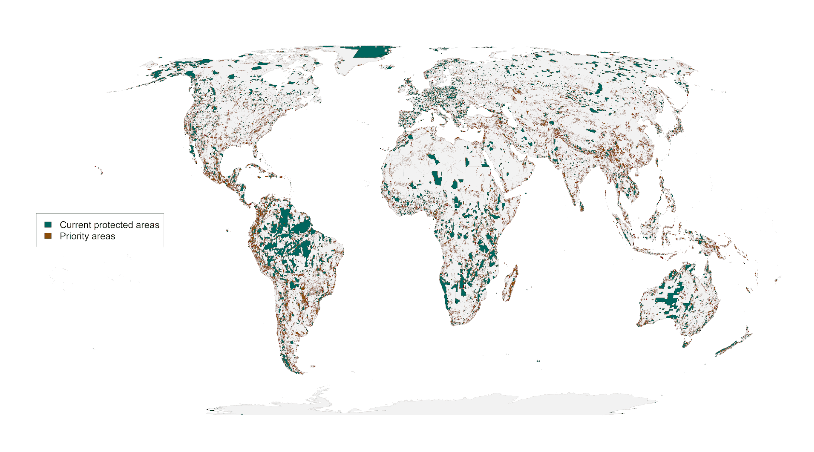

**Figure 1:** Spatial representation of priority areas for protection to account for governance, land use and climate risk. Accounting for these risks to protected area effectiveness to produce more resilient conservation networks would require 23.5% of land surface to reach suitable habitat protection goals[cite Hanson] for vertebrate species from the IUCN Red List of Threatened Species22.

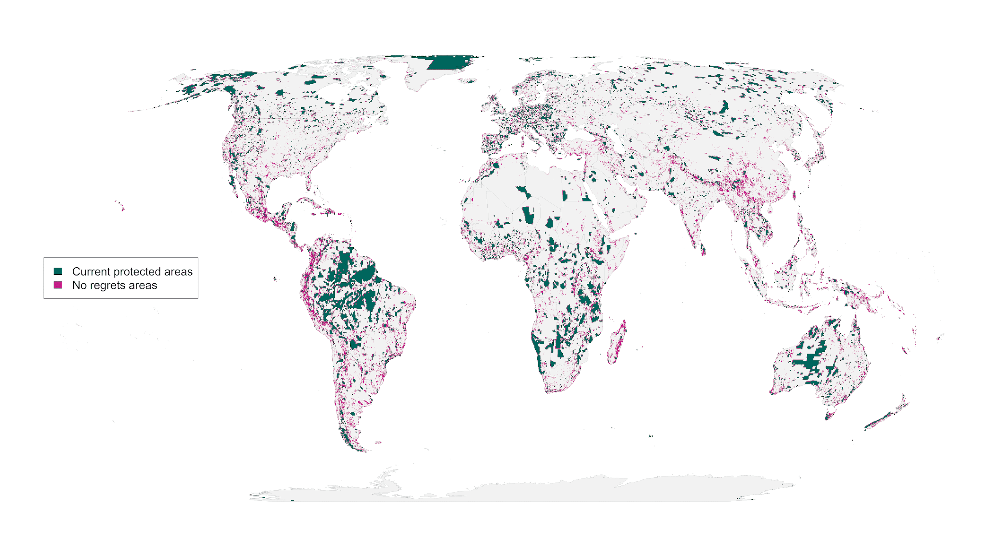 **Figure 2**: “No regrets” areas comprising 8.5 million km2 of land that was identified as priority habitat for protection regardless of the risks included in our analysis.

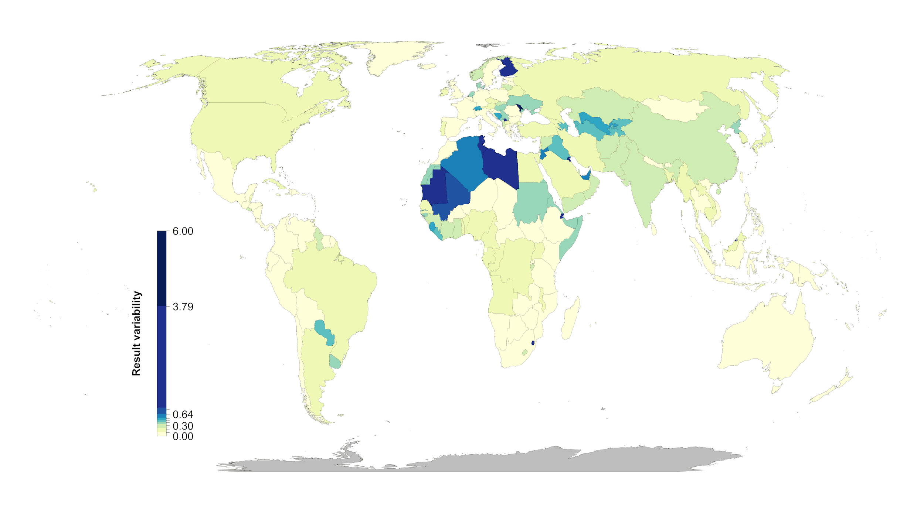

**Figure 3:** Percent country-level variation between the null scenario and the 15 scenarios including risk. Countries whose results are consistent across the 15 scenarios (e.g., Mexico) have low variation, while countries whose results are less consistent across the 15 scenarios (e.g., Finland) have high variation. The kmeans method38 was used to generate class intervals for visualization.

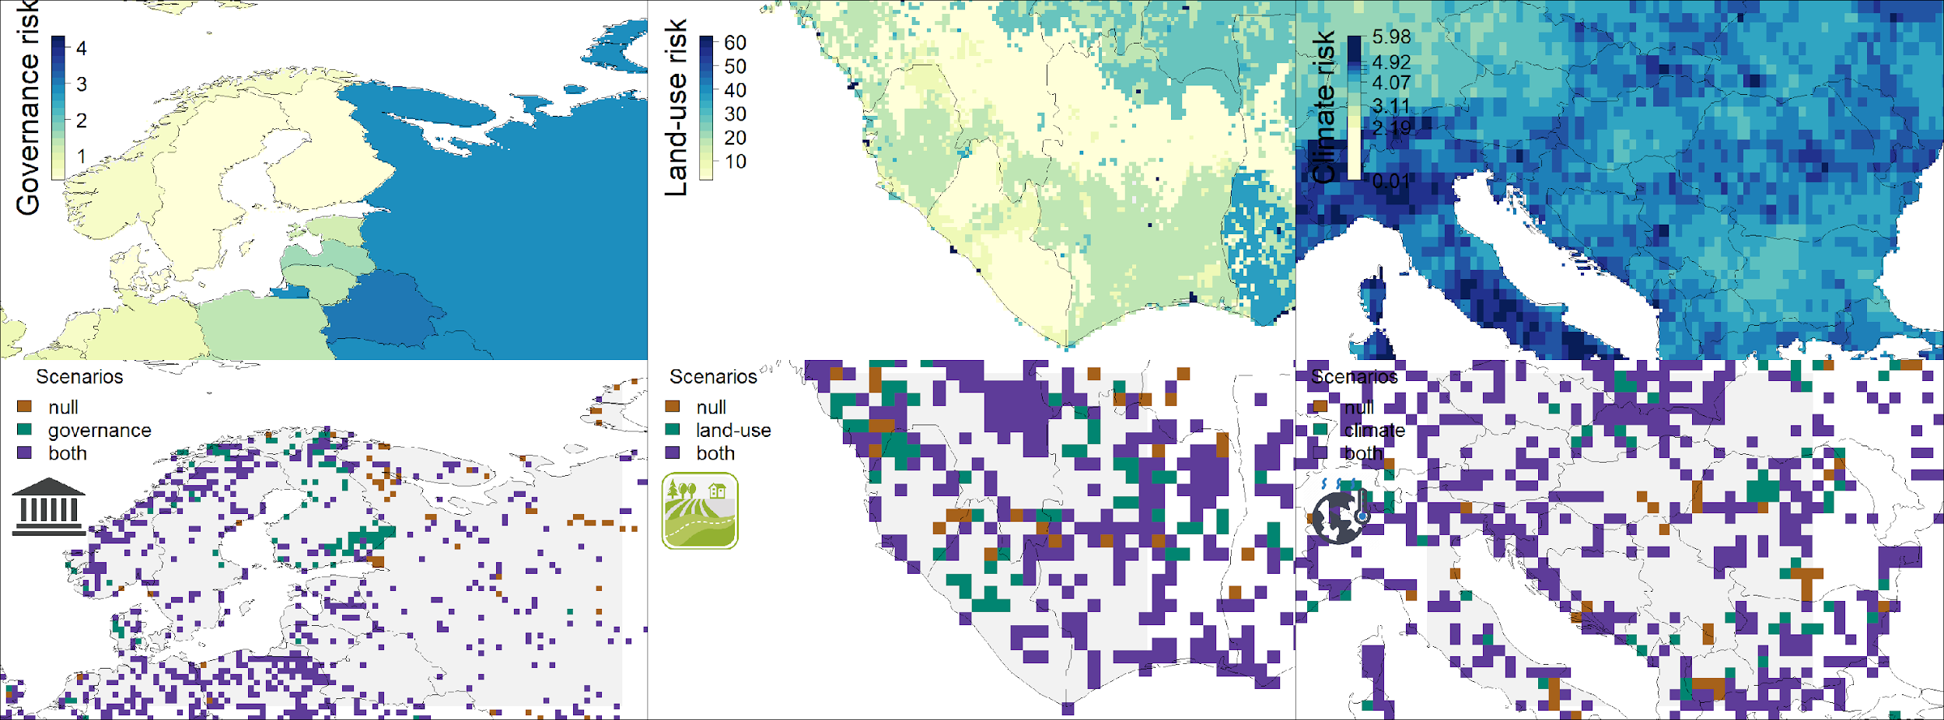

**Figure 4:** Contrast of using individual risk objectives (governance, land-use, climate) to the null scenario of uniform objective structure. The top panels represent the individual risk data for the focal regions. In the bottom panels brown shows null, green the specific risk objective scenario results, and purple where both scenarios agree. The figures show how the spatial configuration of the solutions changes when risk is considered in a scenario. Governance focus is on Finland and Russia, land-use risk on Sierra Leone and Liberia, and climate risk on Serbia, Hungary and Kosovo.

**(Please delete before submission)** Supplementary materials should be included in a separate supplementary materials file. A template for this file can be found at: <http://www.sciencemag.org/sites/default/files/Science_Supplementary_Materials_Word_template.docx>.

**Materials and Methods**

We used a multi-objective optimization approach that incorporated governance, land use and climate constraints to prioritize the conservation of 29,350 vertebrate species. All scenarios we investigated assumed the current global protected area portfolio is locked in. We further created representation targets for each species on the basis area of habitat maps. Targets for the unpartitioned habitat maps were set following standard practices for global gap analyses and prioritizations, except that instead of using the range sizes of species to set the targets, here we used the total extent of suitable habitat for each species following Hanson et al..

*Biodiversity Data*

Species AOH ranges were produced for 10,774 species of birds, 5,219 mammals, 4,462 reptiles and 6,254 amphibians with available IUCN range polygon data following the procedure outlined in Brooks et al. 2019. Species range polygons obtained from the IUCN Red List spatial data portal (IUCN Red List and UN Environment Programme World Conservation Monitoring Centre 2020) and the Birdlife International spatial data zone (BirdLife International and Handbook of the Birds of the World 2019) were first filtered for ‘extant’ range then rasterized to a global 1 km grid in the Eckert IV equal area projection. Individual species range rasters were then modified to only include land cover classes that match the habitat associations for each species. Habitat associations were obtained from the IUCN Red List species habitat classification scheme and were matched to ESA land cover classes for the year 2018 following the crosswalk table presented in Santini et al. 2019. ESA land cover classification data was aggregated from its native 300 m resolution to match the global 1km grid using a majority rule. Species ranges were additionally filtered so that only areas within a species accepted elevational range were included. Global elevation data derived from SRTM was obtained from WorldClim v. 2 (Fick et al. 2017). For bird species, seasonal range codes 1-3 (1=year-round; 2=breeding range; 3=non-breeding range) were processed individually and stored as separate range files where applicable.

*Basic administrative delineations*

National boundaries were derived from the Global Administrative Areas database (<http://gadm.org/>, accessed 2019-10-31). We obtained protected area boundaries from the World Database on Protected Areas (WDPA, [https://www.protectedplanet.net](https://www.protectedplanet.net/)). Following standard procedures for cleaning the protected area dataset41,42, we (i) projected the data to an equal-area coordinate system (World Behrman), (ii) excluded reserves with unknown or proposed designations, (iii) excluded UNESCO Biosphere Reserves43, (iv) buffered sites represented as point localities to their reported area, (v) dissolved boundaries to prevent issues with overlapping areas, and (vi) removed slivers (code available at https://github.com/jeffreyhanson/global-protected-areas). After the protected area data were modified as described above, we overlaid the protected area boundaries with a 10 x 10 km grid covering the Earth. These spatial data procedures were implemented using ArcMap (version 10.3.1) and python (version 2.7.8).

*Governance risk*

Conservation risk due to governance can affect the outcomes of strategies, and effective governance can promote the resilience of conservation in the face of sociopolitical and economic shocks. We used worldwide governance indicators from the World Bank18 to capture these pressures. The indicators include six scaled measures: voice and accountability; political stability and absence of violence; government effectiveness; regulatory quality; rule of law; and control of corruption (see Table S4 for definitions). We chose these indicators because evidence suggests that they reliably predict protected area effectiveness44 and state investment and efforts for biodiversity conservation8. For each country, we used a mean of annual averages of all six measures8 (Figure S1).

*Land use risk*

We used a recently developed global land systems map produced by Kehoe et al.19 to incorporate the risk of land-use change. This map is based on a global land systems map for the year 200045 at a 9.25 km2 spatial resolution, but is refined based on recent land-cover and land-use datasets to a spatial resolution of 1 km2. Kehoe et al.19 further estimated the impact of land use and land use intensity on biodiversity, with data originating from the PREDICTS project46. They first matched their land-systems classes to varying intensity levels for each land-use type (for detailed conversion table, see ref47). This allowed Kehoe et al.19 to calculate average biodiversity loss per land system (relative to an unimpacted baseline) by taking the mean model estimates of biodiversity loss per land-use intensity class from previous work47. The result gives average relative biodiversity gain or loss per land-system class. Here, we used their modelled mean estimates (following Newbold et al.47) of relative percent biodiversity change for each land-system class for species abundance as a measure of the land-use pressure (Figure S2).

*Climate risk*

Velocity of climate change in an instantaneous measurement of how projected temperature increases translates to horizontal velocity on the landscape (Loarie et al. 2009). It is an integration of both the rate of change in average climate and landscape properties that govern how bands of similar temperature redistribute spatially as climate changes. For example, in a region with high topographic diversity, a species may be able to track its climatic niche through relatively small dispersal distances (e.g. 10s or 100s of meters) upslope or downslope. By contrast, keeping pace with preferred climate under the same magnitude of temperature rise in the plains may require much larger dispersal distances – 100s or 1000s of kilometers. The local velocity of climate change, although a purely physical property, has biological relevance when linked with individual species level dispersal capacity. Velocity of historical climate change since the last glacial maximum has been suggested as a major driver of patterns of species endemism (e.g. Sandel et al. 2011) and is commonly used as a biologically scaled metric of climate exposure (e.g. Garcia et al. 2014). Velocity of future temperature change used here follows the method of Loarie et al. 2009 – and is essentially the ratio of the projected temporal rate of change (C/year) to the spatial rate of change (C/km). Projected temporal rate of change is based on the 2050 projection for mean annual temperature from the CMIP6 model and the baseline (1960-1990) temperature available from Worldclim v1.4. Spatial rate of change was derived from 30 arc second elevation data and calculated with the ‘terrain’ function from the R ‘raster’ package.

We also explored an alternative measure of climate risk: exposure to extreme events. Anthropogenic climate change is affecting the frequency and duration of extreme heat events48,49. Exposure to these events can adversely affect human populations50–52 and natural systems13,53. For species in natural systems, these events can further the decline and extirpation of populations, increasing the chances of extinction13,54. EHE and ECE can also promote the formation of novel ecosystems53, generate enhanced selection pressures55,56, and change the phenology of life history events57,58. There are a number of climate indices that have been used to estimate the occurrence of these events59,60. These indices are often context specific and there is little consensus on the most appropriate technique61.

For this alternative measure, we estimated climatic risk based on the estimated trend in the annual proportion of days containing extreme heat events from 1979 to 201917. Extreme heat events were estimated using hourly air temperature at 2 m above the surface and gridded at a 31 km (0.28125° at the equator) spatial resolution (DOI: 10.24381/cds.adbb2d47). The temperature data was acquired from the European Centre for Medium-Range Weather Forecasts (ECMWF) fifth generation atmospheric reanalysis of the global climate (ERA5)62,63. The approach first extracted daily minimum and maximum temperature for each grid cell over the 41-year period. To reduce the influence of warming trends, the daily minimum and maximum temperature was then detrended across years for each day and grid cell using empirical mode decomposition (EMD)64,65. The occurrence of extreme heat events was estimated using the following approach: The detrended minimum and maximum temperature data was treated as normally distributed across years for each day and grid cell. The probability density function for the detrended minimum and maximum temperature was then estimated using the mean and standard deviation calculated across years for each day and grid cell. Extreme heat events occurred when the probabilities for both minimum and maximum temperature on a given day and grid cell were within the 0.95-1.00 quartile of the probability density function. The trend in the annual proportion of days containing extreme heat events for each year was calculated for each grid cell using beta regression with a logit link function and an identity function in the precision model66,67. (Figure S7). See La Sorte et al.20 for additional details.

*Multi-objective optimization of pressure reduction*

We processed all data described previously to a 10 x 10 km resolution and clipped data to the extent of land based on the global administrative areas database. We then developed an extension on the minimum set problem, which has the goal to identify a set of sites within a planning area that represents all conservation targets in the fewest number of sites24. Instead of including a single objective in the problem formulation, we expanded it to include multiple objectives. Specifically, we used a hierarchical (lexicographic) approach that assigns a priority to each objective, and sequentially optimizes for the objectives in order of decreasing priority. At each step, it finds the best solution for the current objective, but only from among those that would not degrade the solution quality for higher-priority objectives. We considered up to three objectives in our prioritization scenarios, i) governance risk, ii) land-use risk, and iii) climate risk. To compare different scenarios, we calculated solutions for each unique objective combination (n = 15), as well as one where we use a constant objective function as the null scenario, as the order of the hierarchy can influence the results.

In systematic conservation planning, conservation features describe the biodiversity units (e.g., species, communities, habitat types) that are used to inform protected area establishment. Planning units describe the candidate areas for protected area establishment (e.g., cadastral units). Each planning unit contains an amount of each feature (e.g., presence/absence, number of individuals). A prioritization describes a candidate set of planning units selected for protected establishment. Each feature has a representation target indicating the minimum amount of each feature that ideally should be held in the prioritization (e.g., 50 presences, 200 individuals). To minimize risk, we have a set of datasets describing the relative risk associated with selecting each planning unit for protected area establishment. Thus, we wish to identify a prioritization that meets the representation targets for all of the conservation features, with minimal risk.

Let I denote the set of conservation features (indexed by i), and J denote the set of planning units (indexed by j). To describe existing conservation efforts, let pj indicate (i.e., using zeros and ones) if each planning unit j ∈ J is already part of the global protected area system. To describe the spatial distribution of the features, let Aij denote (i.e., using zeros and ones) if each feature is present or absent from each planning unit. To ensure the features are adequately represented by the solution, let ti denote the conservation target for each feature i ∈ I. Next, let D denote the set of risk datasets (indexed by d). To describe the relative risk associated with each planning unit, let Rdj denote the risk for planning units j ∈ J according to risk datasets d ∈ D.

The problem contains the binary decision variables xj for planning units j ∈ J.

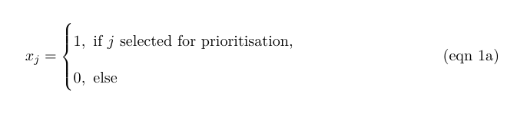

The reserve selection problem is formulated following:

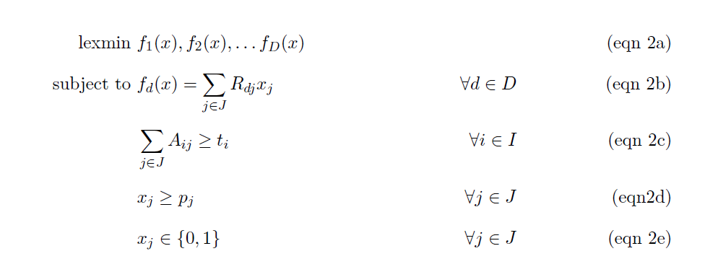

The objective function (eqn 2a) is to hierarchically (lexicographically) minimize multiple functions. Constraints (eqn 2b) define each of these functions as the total risk encompassed by selected planning units given each risk dataset. Constraints (eqn 2c) ensure that the representation targets (ti ) are met for all features. Constraints (eqn 2d) ensure that the existing protected areas are selected in the

solution. Finally, constraints (eqns 2e) ensure that the decision variables xj contain zeros or ones.

For all scenarios we locked in current protected areas. Following Hanson et al.[cite], we used flexible targets for suitable habitat based on species’ ranges. Species with less than 1,000 km2 of suitable habitat were assigned a 100% target (1,802 amphibians, 893 avian and 645 mammalian species), species with more than 250,000 km2 of suitable habitat were assigned a 10% target (712 amphibians, 4,518 avian and 1,868 mammalian species) and species with an intermediate amount of suitable habitat were assigned a target by log-linearly interpolating values between the previous two thresholds (2,683 amphibians, 5,190 avian and 2,557 mammalian species). Migratory bird species were assigned targets for each seasonal distribution separately). Additionally, to prevent species with very large suitable habitats from requiring excessively large amounts of area to be protected, the targets for species’ distributions larger than 10,000,000 km2 were capped at 1,000,000 km2. This upper limit affected only 206 (1%) species, and sensitivity analyses showed that it had little effect on our results. We acknowledge that these targets are arbitrary; however, they are more precise than previous targets based on species’ ranges (which can contain a large amount of unsuitable habitat), and accounts for the increased vulnerability of species with smaller range sizes, as well as the difficulty in conserving all habitat for species that occur over large areas.

**Table S1.** Scenarios explored and global protection results. The risk factor order represents the order risk factors were included in the hierarchical prioritization. (G = governance, L = land use, C = Climate).

|  |  |  |
| --- | --- | --- |
| **Scenario** | **Risk factors included** | **Global land area protected [%]** |
| **null** | - | 21.27 |
| **1** | G | 21.35 |
| **2** | L | 22.31 |
| **3** | C | 23.79 |
| **4** | G > L | 21.93 |
| **5** | L > G | 22.18 |
| **6** | G > C | 23.78 |
| **7** | C > G | 23.31 |
| **8** | L > C | 23.52 |
| **9** | C > L | 22.99 |
| **10** | G > L > C | 23.52 |
| **11** | G > C > L | 23 |
| **12** | L > G > C | 23.5 |
| **13** | L > C > G | 23.08 |
| **14** | C > G > L | 22.3 |
| **15** | C > L > G | 22.99 |

**Table S2**. Country specific results for the 15 scenarios investigated. Numbers represent % of land area of a country selected (including existing protected areas).  
(As an example 5 countries included here, full list in csv. N = null, G = governance, L = land use, C = Climate)   
<https://drive.google.com/file/d/1eD4y4K8XG4nxnRL5fNtiTqzuqfIJ_DfB/view?usp=sharing>

|  |  |  |  |  |  |
| --- | --- | --- | --- | --- | --- |
|  | Afghanistan | Åland | Albania | Algeria |  |
| N | 15.95 | 57.14 | 38.46 | 10.62 |  |
| G | 14.95 | 85.71 | 35.66 | 7.71 |  |
| L | 17.03 | 85.71 | 43.71 | 10.32 |  |
| C | 19.25 | 57.14 | 46.15 | 13.69 |  |
| GL | 15.87 | 85.71 | 37.41 | 8.94 |  |
| LG | 16.55 | 100 | 38.11 | 11.59 |  |
| GC | 19.3 | 57.14 | 46.5 | 13.71 |  |
| CG | 17.89 | 71.43 | 39.16 | 12.74 |  |
| LC | 17.8 | 71.43 | 44.06 | 13.07 |  |
| CL | 19.52 | 57.14 | 40.56 | 13.36 |  |
| GLC | 17.8 | 57.14 | 43.71 | 13.15 |  |
| GCL | 19.44 | 57.14 | 41.96 | 13.38 |  |
| LGC | 17.81 | 57.14 | 44.06 | 13.05 |  |
| LCG | 16.58 | 85.71 | 38.11 | 12.36 |  |
| CGL | 17.52 | 85.71 | 43.36 | 12.4 |  |
| CLG | 19.52 | 57.14 | 40.56 | 13.36 |  |

**Table S3. Governance risk score table (see csv)**

(As an example Afghanistan – Barbados are included below)<https://drive.google.com/file/d/1g_LePBfCbphXzTiCOXCzQtNLSSYoV6me/view?usp=sharing>

|  |  |  |  |
| --- | --- | --- | --- |
| Country.Name | Country.Code | MeanIndex | SDIndex |
| Afghanistan | AFG | -1.65038 | 0.16074 |
| Albania | ALB | -0.28043 | 0.219515 |
| Algeria | DZA | -0.86838 | 0.121774 |
| American Samoa | ASM | 0.747997 | 0.127264 |
| Andorra | AND | 1.359029 | 0.04054 |
| Angola | AGO | -1.16429 | 0.217384 |
| Anguilla | AIA | 1.138708 | 0.225908 |
| Antigua and Barbuda | ATG | 0.687351 | 0.143042 |
| Argentina | ARG | -0.19472 | 0.196541 |
| Armenia | ARM | -0.29545 | 0.091655 |
| Aruba | ABW | 1.181311 | 0.090913 |
| Australia | AUS | 1.591282 | 0.033469 |
| Austria | AUT | 1.559385 | 0.080972 |
| Azerbaijan | AZE | -0.84662 | 0.123512 |
| Bahamas, The | BHS | 0.991142 | 0.212122 |
| Bahrain | BHR | 0.067606 | 0.189151 |
| Bangladesh | BGD | -0.8678 | 0.131258 |
| Barbados | BRB | 1.154432 | 0.145899 |

**Table S4.**

|  |  |
| --- | --- |
| **Indicator** | **Definition**  Source: World Bank, 2020 (<https://datacatalog.worldbank.org/dataset/worldwide-governance-indicators>) |
| Voice and accountability | “Voice and accountability captures perceptions of the extent to which a country's citizens are able to participate in selecting their government, as well as freedom of expression, freedom of association, and a free media.” |
| Political stability and absence of violence | “Political Stability and Absence of Violence/Terrorism measures perceptions of the likelihood of political instability and/or politically-motivated violence, including terrorism.” |
| Government effectiveness | “Government effectiveness captures perceptions of the quality of public services, the quality of the civil service and the degree of its independence from political pressures, the quality of policy formulation and implementation, and the credibility of the government's commitment to such policies.” |
| Regulatory quality | “Regulatory quality captures perceptions of the ability of the government to formulate and implement sound policies and regulations that permit and promote private sector development.” |
| Rule of law | “Rule of law captures perceptions of the extent to which agents have confidence in and abide by the rules of society, and in particular the quality of contract enforcement, property rights, the police, and the courts, as well as the likelihood of crime and violence.” |
| Control of corruption | “Control of corruption captures perceptions of the extent to which public power is exercised for private gain, including both petty and grand forms of corruption, as well as "capture" of the state by elites and private interests.” |

**Figure S1. Governance risk (yellow = low, blue= high)**

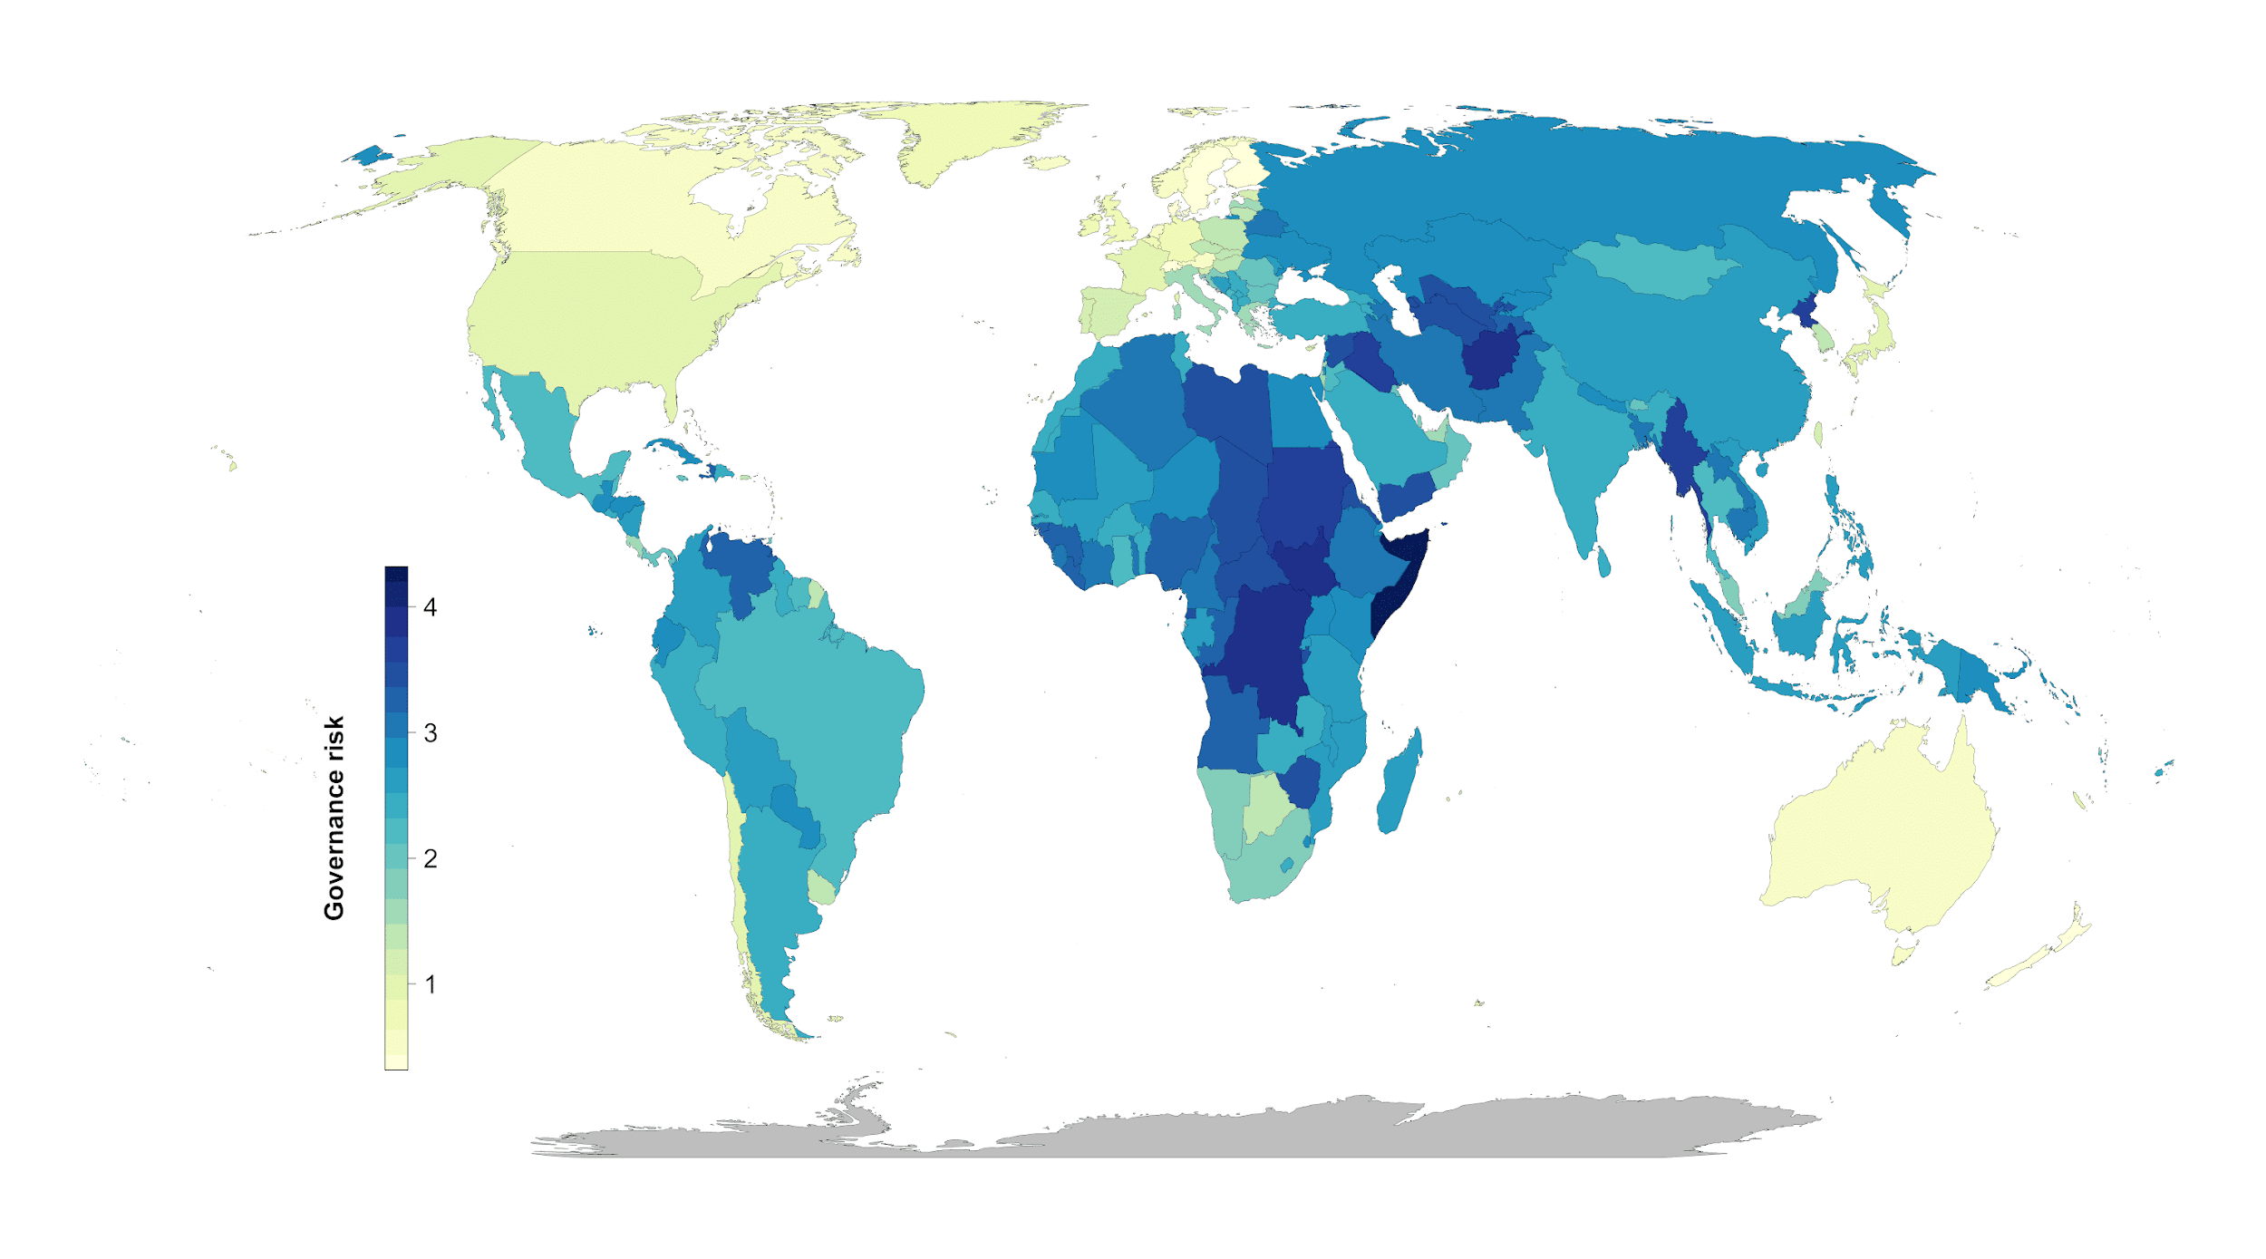

**Figure S2. Land systems risk (yellow = low, blue= high)**

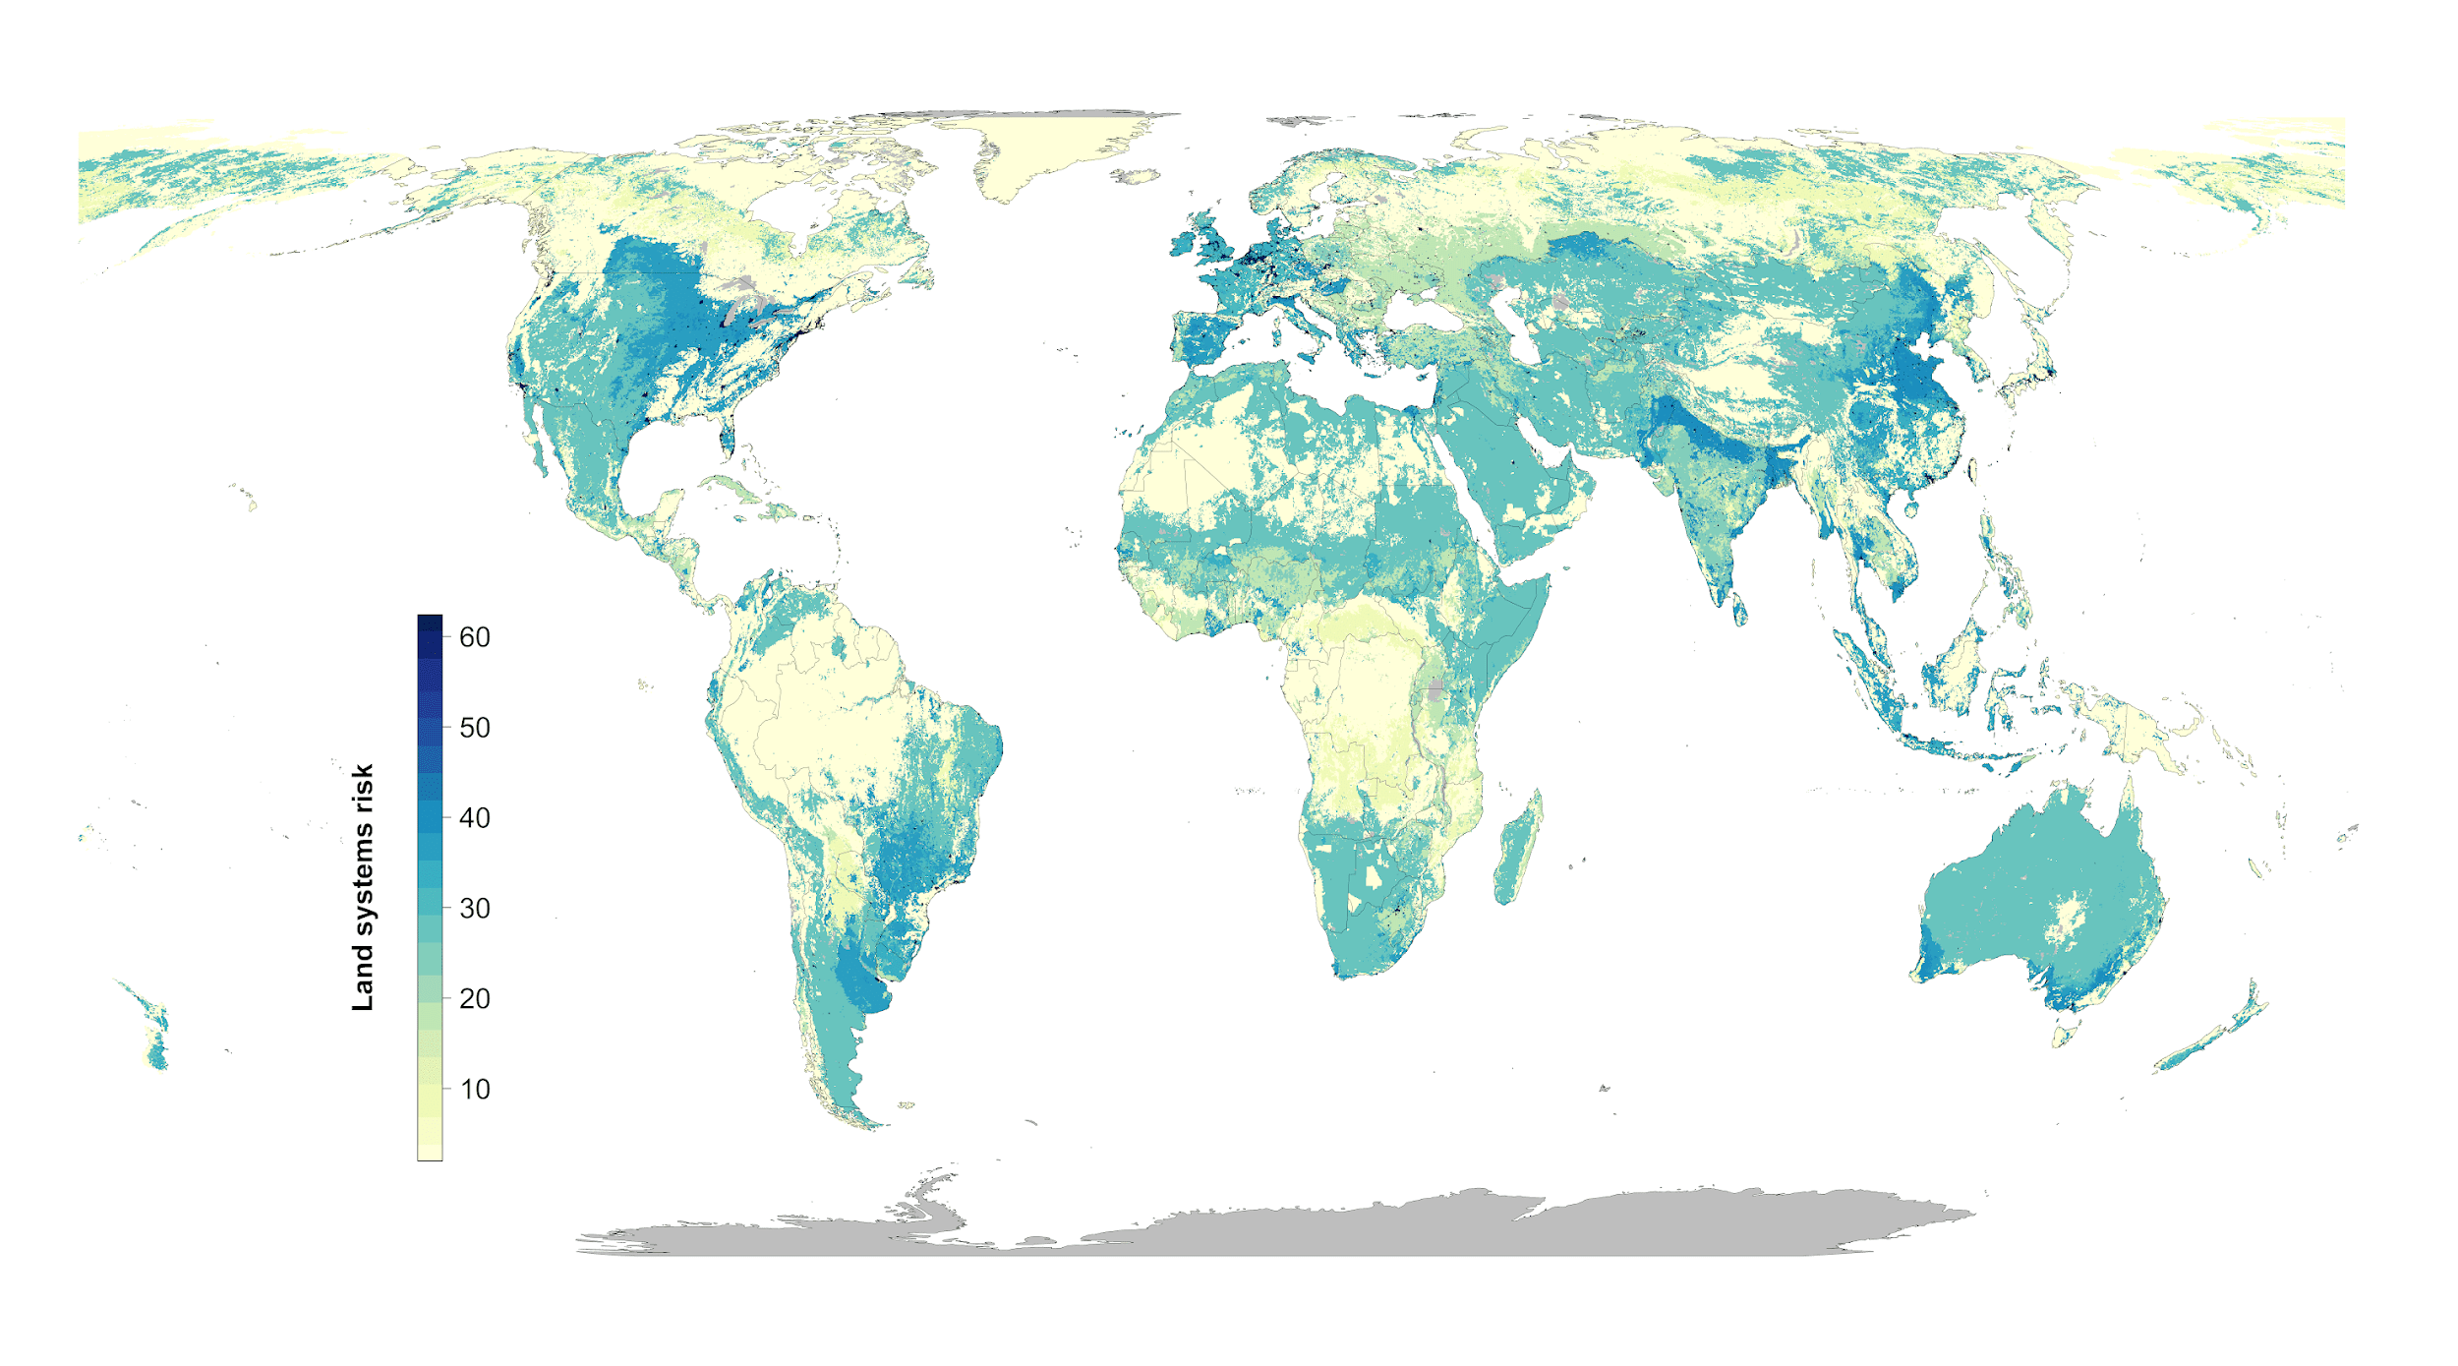

**Figure S3. Climate risk (extreme heat events) (yellow = low, blue= high)**

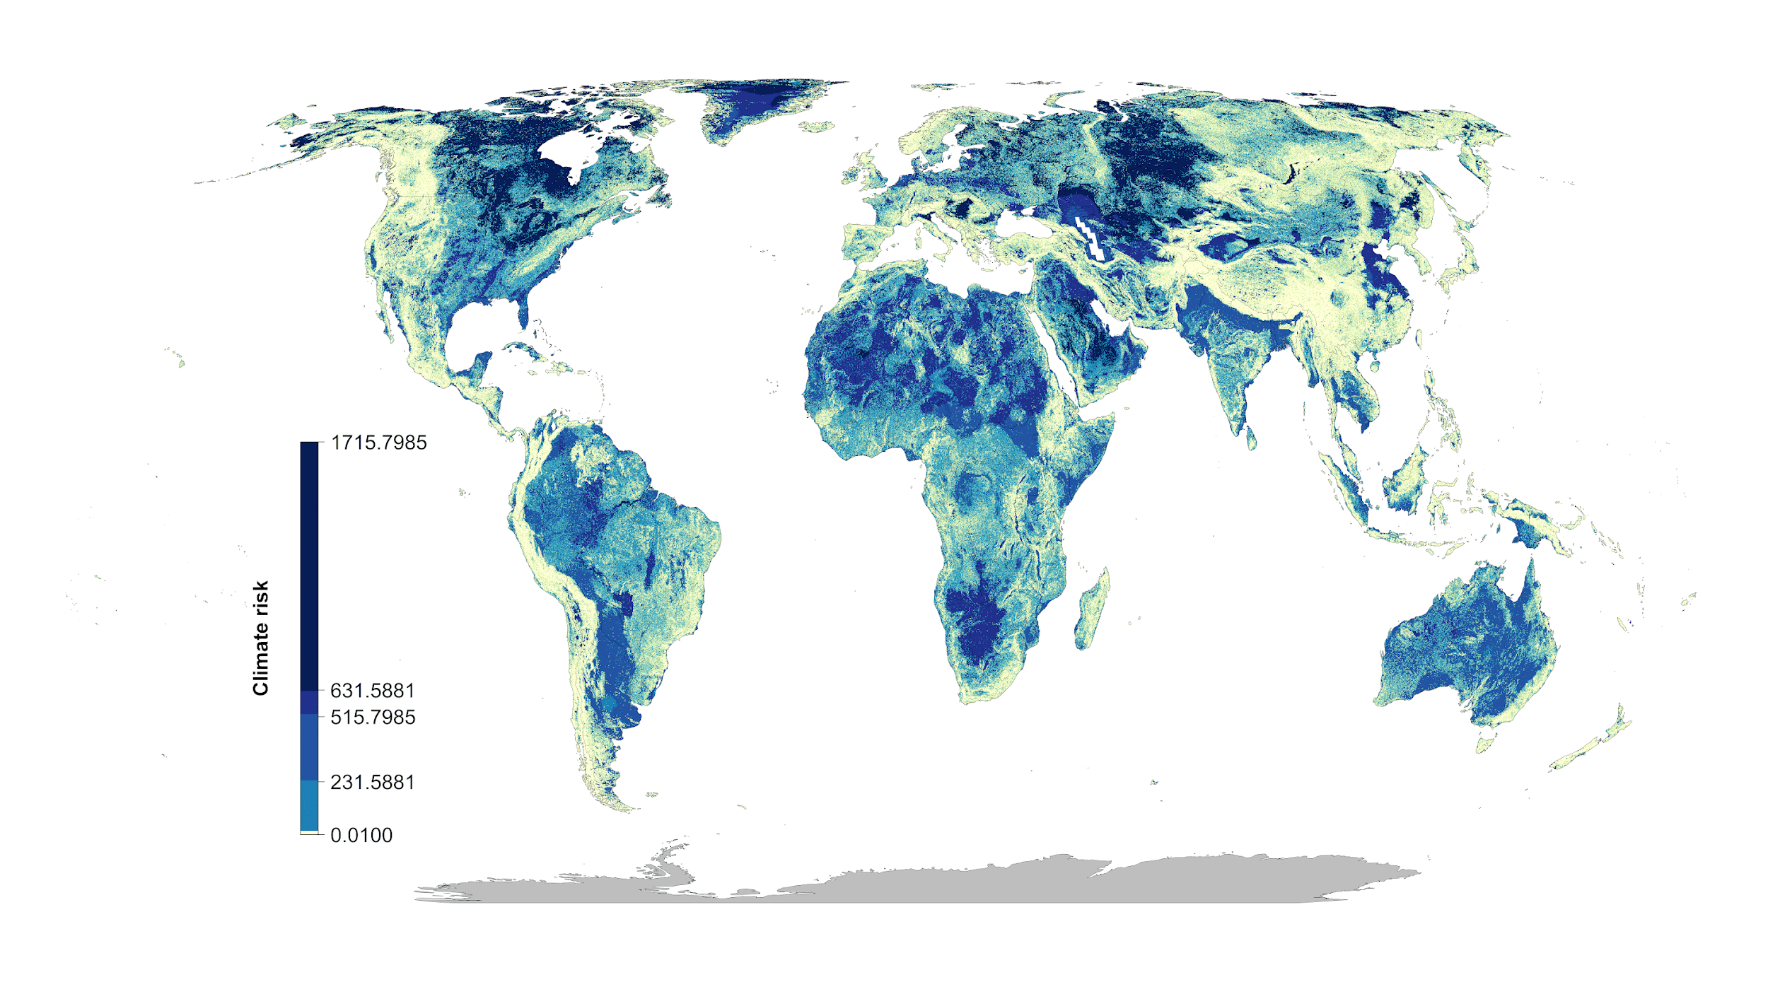

**Figure S4: Scenario overlap. green = protected areas. Color gradient from yellow (one scenario) to red (15 scenarios) = overlap.**



**Figure S5. Areas of high scenario overlap (>10 scenarios, green) compared to Meyers et al. biodiversity hotspots (blue).**

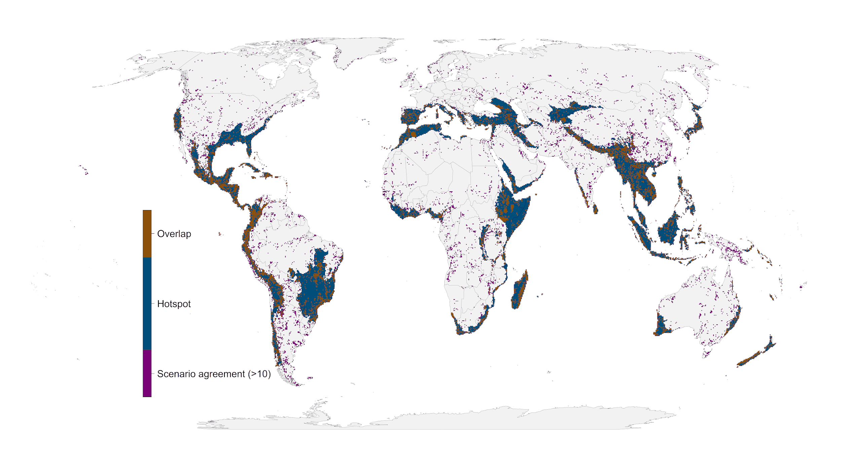

**Figure S6: Influence of average country specific risk factors on the optimization outcomes compared between null scenario and the scenarios including one of the risk factors. Each data point represents the results for one country. The fitted blue lines and 95% confidence bands are from ordinary least-squares regression.**

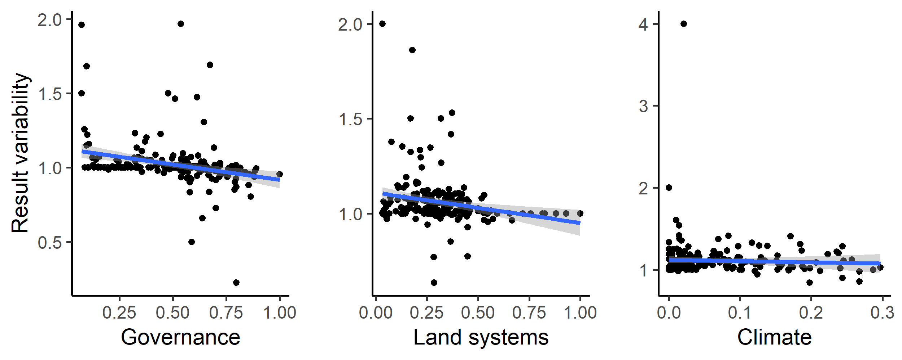

**Figure S7. Alternative climate risk metric (extreme heat events) (yellow = low, blue= high)**

**Figure S8: Alternative climate risk scenario “No regrets” areas that were identified as priority habitat for protection regardless of the risks included in our analysis.**

**Figure S9: Alternative climate risk scenarios percent country-level variation between the null scenario and the 15 scenarios including risk. Countries whose results are consistent across the 15 scenarios (e.g., Brazil) have low variation, while countries whose results are less consistent across the 15 scenarios (e.g., Sweden) have high variation. The kmeans method38 was used to generate class intervals for visualization.**

